Time Sheet

PAS allows the project team members to record time spent in pre-defined categories of project related and non-project related tasks in Time Sheet function.
The time spent on a given project are used to calculate project cost when used together with project expenses, procurement and subcontractor costs provides financial view (profit/loss) of the project. Thus, for the users who didn’t record their time sheet correctly may affect their expense claim.
Time recorded by project team members requires project manager approval before it becomes valid data in PAS.

It has four options which as shown in the diagram 1.
- Time Sheet Entry
- Time Sheet Forecast
- Time Sheet Approval
- Time Sheet CAF Update

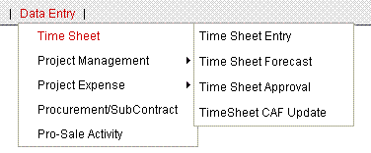
Diagram 1: Time Sheet

Time Sheet Entry

This section offers a time sheet data table for user to maintain or update the time allocation. It shows a configuration screen (diagram 2) to confirm who is going to maintain the time sheet records. The default user is login user.
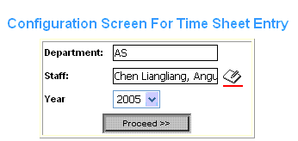
Diagram 2: Time Sheet Entry Configuration

The book-note icon with red underline only appears for who has certain permissions which may allow this login user to select other staff and enter time sheet for them.

After click the “Proceed” button, a time period table (diagram 3) appears for specified user to choose a time period. It shows the list of all weeks for the current year, including time period, total hours maintained, and last updated information. It shows “NA” for total hours by default.
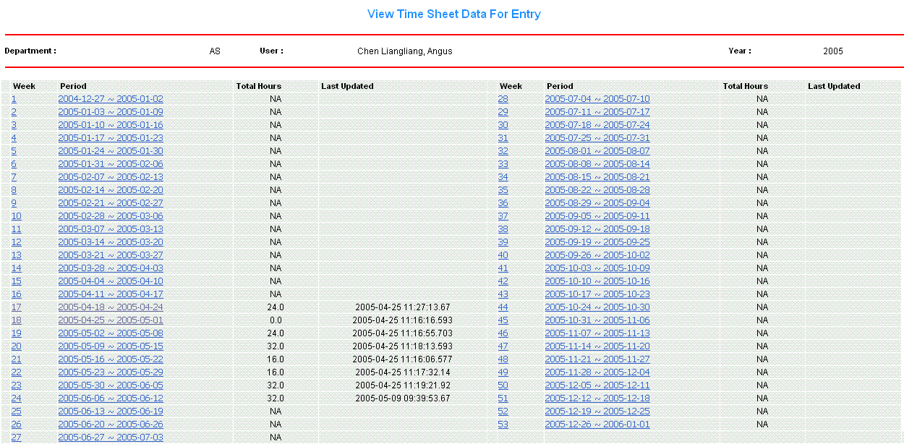
Diagram 3: Time Period Table

On the home page when you just get access into the PAS system, it shows the AO fiscal calendar. Comparing the close date of the current fiscal month with today’s date, users are not allowed to key in any time sheet records if today’s date is beyond the close date.

User may start to key in the time sheet in Time Sheet Maintenance window (diagram 4) after selects a time period.

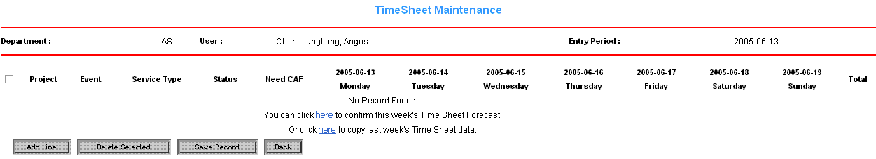
Diagram 4: Time Sheet Maintenance window

When the user begins to maintain the time sheet data for a new week, system will prompt the user no-result information, as there is no corresponding data. The no-result information looks like “No Record Found. You can click here to fetch this week’s forecast data definition or click here to fetch last week time sheet record”. User may take following ways to maintain time sheet data for this week.
- Manually create the new time sheet record by clicking “Add Line” button;
- Or click link provided to get forecasted time sheet data for this week;
- Or click link provided to get last week maintained time sheet data for last week;

User has to select a project if wants to create a new time sheet record. By clicking “Add Line” button, project selection window (diagram 5) appears for user to select a proper project.
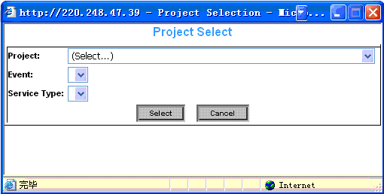
Diagram 5: project selection window

User can only see the list of projects which are relevant to the user. If you are the member of a particular project which is not available for you to choose from the list, please contact with your project manager.

After selecting a proper project, user has to select a correct event (diagram 6). Choosing wrong event may directly affect the total cost of the project and your utilization percentage.
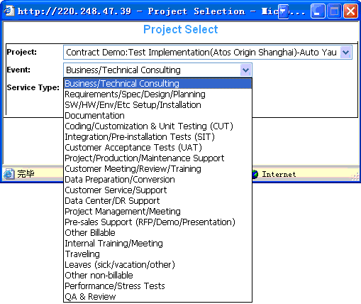
Diagram 6: Event selection window

User has to add another time sheet record if user is working on a project with different events during a week time.
After selecting a proper event, user has to select a correct service type (diagram 7). Service type list may vary with different project, they are predefined when the project master information are set up into the PAS system. Normally, for Time & Material category project, service types are like AC, TC, BC or PM. For Fixed Price category project, service types are like Phase 1, Phase2 and so on. Choosing wrong service type means choosing wrong working rate, which may directly affect the total cost of the project.
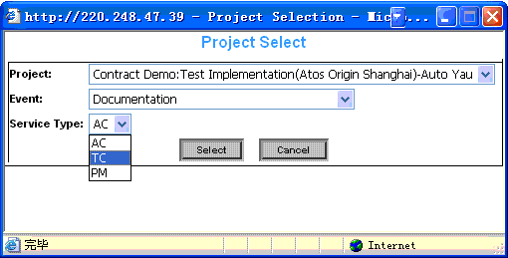
Diagram 7: Service Type selection window
Once you have selected the correct project, event, and service type, you are ready to enter this week’s time sheet (diagram 8).

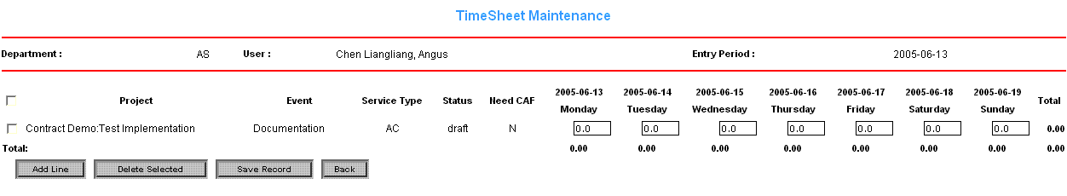
Diagram 8: Time Sheet Entry

“Status” field help user identify if this time sheet record has been approved by project manager or not. “Need CAF” field is to identify if the selected project needs CAF from customer or not. If yes, user has to provide relevant signed CAF and Project Assistant will need to verify CAF later to ensure the confirmed working hours for staffs.

You may key in the hours between 0 and 8. Over time is not being taken account into system. You may enter your time sheet for many different projects in one week by clicking ”Add” button to select different projects. Once the user has done the time sheet data maintenance work, user may save the work by clicking “Save Record” button and may also choose to update the saved work until it is approved by the project manager. User is not allowed to modify and delete the maintained time sheet records after being approved by project manager (diagram 9).

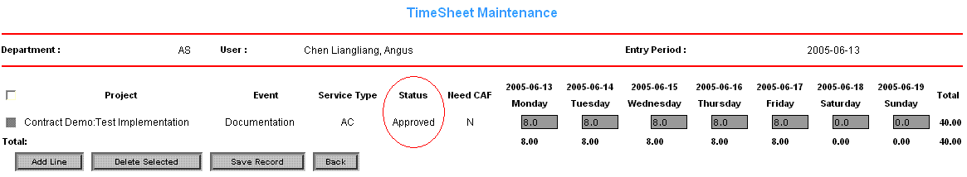
Diagram 9: Approved Time Sheet

If the time sheets entered by staff are rejected by project manager, you need to confirm with your project manager to check why they are not being approved (diagram 10). And if necessary, after modified the time sheet records correctly, you need to submit them again. Thus, it is very important for users to check if their time sheets are getting rejected or not before every fiscal month closes.

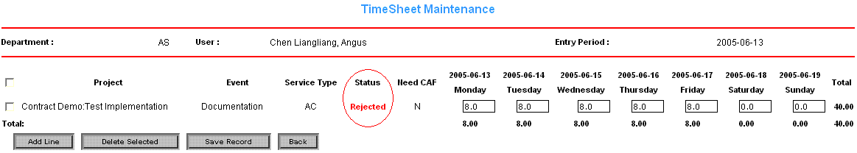
Diagram 10: Rejected Time Sheet

Important Notes for Time Sheet Entry

As the general working calendar defines that the total working hour for a week is 40 hours, we have built one general internal project called I050010001:HRM OverHead
(diagram 11). This project will be available for you to choose at anytime. If you are taking training, leaving, internal meeting, or in the office not doing any projects, please lodge your time sheet on this project. Therefore you have to enter total 40 hours for any particular week no matter you are working in the projects or staying in the office.

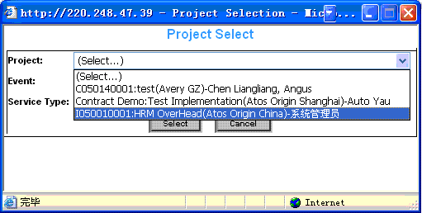
Diagram 11: Internal HRM OverHead Project

Time Sheet Forecast

It is suggested that all employees need to maintain the time sheet forecast in order for Project Managers and Resource Manager to track and manage human resources. This function allows the staffs to key in their future job arrangements. Normally 4 weeks of time sheet forecast will be needed.

All the operations and procedure logics are same as maintaining Time Sheet Entry. There is only one exception in which you may not see the desired project from the list. In that case, the desired project master information probably has not been built into the system. Users may still forecast their future time sheet by key in the “Description” box (diagram 12)

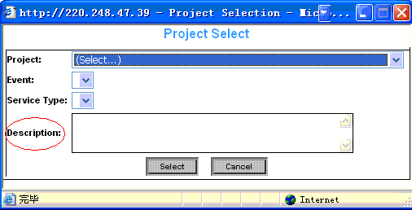
Diagram 12: Enter description if the desired project is not available

If the desired project is not available to select, please enter forecast description instead of selecting any projects.

Important Notes for Time Sheet Forecast

User may only forecast the time sheet records from next week, cannot forecast the figure for the current week. The over-date forecasted time sheet data can only be checked and cannot be modified any more;

Time Sheet Approval

This section is for project managers to approve project members’ time sheet records.
Project Manager needs to check and approve the project members’ time sheet records in order to ensure the authenticity and validity of time sheet records. And they need complete this job at least before the fiscal month close.

The configuration screen (diagram 2) will confirm who as the project manager and selects a time period from the time period table (diagram 3) to approve time sheet.

Project managers may choose the different view for the specified week time sheet by selecting different status (diagram 13).
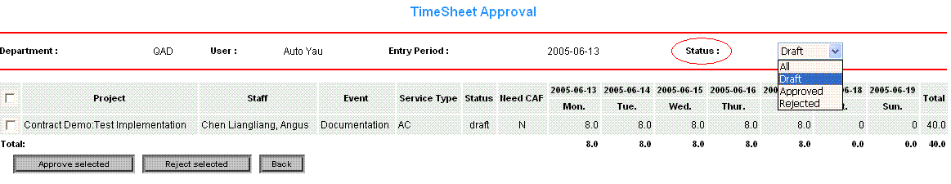
Diagram 13: Time Sheet Approval

Project manager simply ticks the check box in the first column for the corresponding project and click “Approve Selected” button for approval or click “Rejected Selected” for rejection. The project managers may only approve the time sheet records with “Submitted” status, but can reject with both “Submitted” and “Approved”. “Rejected” time sheets also need to be approved if they are correctly modified by staffs.

Important Notes for Time Sheet Approval

All actions for Time Sheet Approval must be done before the fiscal month is closed. If the submitted time sheet records are not getting approved after the fiscal month closed, the cost will not be taken account into the analysis report for that fiscal month, and the time sheet records will be seen as invalid data.

Time Sheet CAF Update

This section is for project manager assistants to update project members’ CAF if the project with member’s time allocation needs CAF. Project Manager Assistant (PA) needs to update the relevant CAF into system once get CAF provided from staffs.

PA has permission to choose desired staff whose CAF need to be updated from configuration screen (diagram 14) by click book-note icon with red underline.

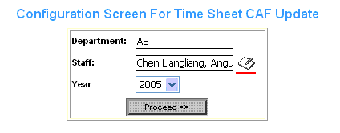
Diagram 14: CAF Update Configuration

After selects the proper staff, PAS may start to update the relevant CAF (diagram 15).

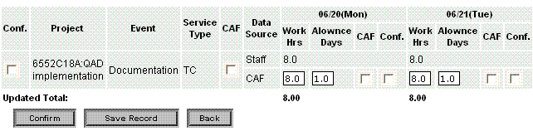
1
2
3
4
5
6

Diagram 15: CAF Update

Fields definition:
- Overall confirmation checkbox is to check all confirmation checkbox for the particular week records.
- Overall CAF checkbox is to check all CAF checkbox for the particular records.
- Based on the CAF provided, PA may verify the work hour.
- PA may also update allowance days if necessary. This checkbox only appears when project has customer paid allowance rate, and allowance amount charged to customer will be the verified allowance days * customer paid allowance rate.
- Tick CAF checkbox if has this day’s CAF provided.
- Tick confirmation checkbox to confirm the verified allowance days.

Click “Confirm” button when all necessary update actions have done for this week.

